Food Price Trend Analysis in Nigeria (2016–2024)

Prepared by
Akimu Odunola

Organization

Nithub AI Ecosystem

9 march 2026

1. Introduction
Food prices are an important indicator of economic conditions and household welfare. Changes in food prices affect purchasing power, food accessibility, and overall living standards. Analyzing how these prices evolve over time helps reveal patterns related to inflation, supply constraints, and market behavior. This report examines food price data collected between January 2016 and April 2024. The objective is to explore long-term price movements, compare price levels across vendors, and identify key patterns among commonly consumed food items. The analysis provides an overview of how food prices have changed over time and highlights factors that may influence price variation.

2. Data Description
The dataset contains food price observations collected over a period of more than eight years, covering January 1, 2016 to April 22, 2024. Each observation includes information about the date, food item, price, vendor type, store name, and geographic coordinates represented by latitude and longitude. Seventeen food items are included in the dataset. Among them, oil, tomato, sugar, rice, and yam appear most frequently. These items represent common household staples and therefore provide useful insight into everyday food costs. The data was collected from two main vendor categories: supermarkets and government sources. Most observations come from supermarkets and online retail platforms, while a smaller portion originates from government price monitoring systems. Retail platforms appearing in the dataset include Chowdeck, Glovo-Shoprite, Glovo-Spar, Mano, and the National Bureau of Statistics.

3. Data Preparation
Several preprocessing steps were carried out before the analysis. Missing values and inconsistent entries were reviewed and handled to improve data quality. The location field was separated into latitude and longitude variables to allow geographic analysis. The date column was converted into a proper date time format so that time-based analysis could be performed. After conversion, the dataset was sorted chronologically to make it easier to observe long-term price trends and seasonal patterns.

4. Price Trends over Time
Food prices were examined across daily, monthly, and yearly time scales. A consistent pattern emerges across most food items. Prices remain relatively stable between 2016 and 2019, followed by a gradual increase beginning around 2020. The rise becomes much more pronounced in 2024, where several food items show sharp price increases.
Rice provides a clear example of this trend. The monthly average price of rice increases slowly for several years before rising sharply in early 2024. Similar patterns appear across other staple foods, suggesting that the increase is part of a broader market trend rather than an isolated change affecting a single commodity. One notable exception is salt, which displays a slightly decreasing trend over the same period.
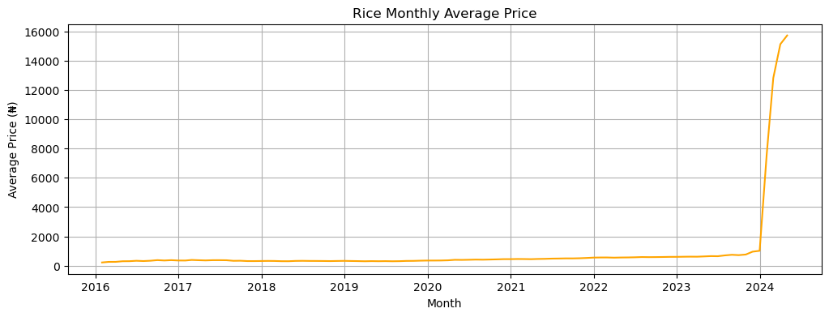 | 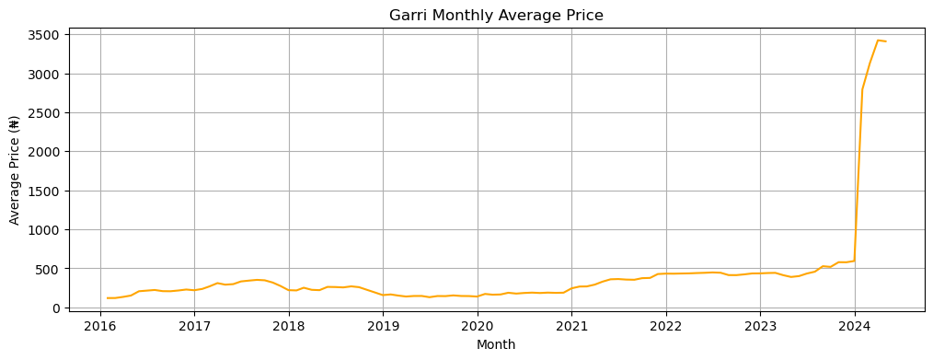

5. Price Extremes
The dataset also reveals significant variation between the lowest and highest recorded prices for some food items. Rice records the highest price observed in the dataset, reaching 138,999.99 Naira in March 2024. Its lowest recorded value appears in 2016 at approximately 29 Naira. Tomato also shows strong fluctuations, with a peak price of about 90,000 Naira in early 2024. For most food items, the highest recorded prices occur in the most recent period of the dataset. This reinforces the observation that food prices have risen considerably in recent years.

6. Vendor Price Comparison
Price levels differ noticeably between vendor types. Supermarket prices are substantially higher than prices recorded from government sources. The average price recorded for supermarkets is approximately 5,606 Naira, while the average government price is about 739 Naira. This difference may reflect variations in supply chains, distribution costs, packaging, and retail markups associated with supermarket sales.
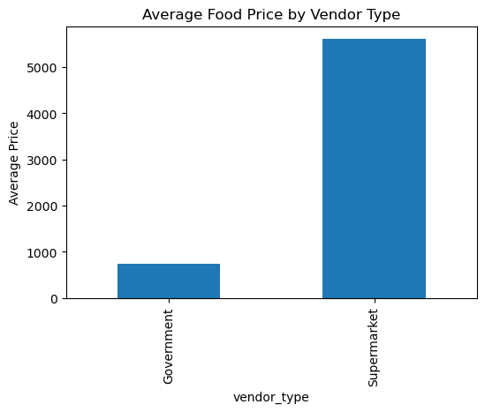

7. Weekly Price Patterns
To examine short-term variations, prices were compared between weekdays and weekends. The results show almost no difference between the two periods. This indicates that daily demand cycles have little influence on food prices within the dataset. Instead, longer-term economic conditions appear to be the main driver of price changes.
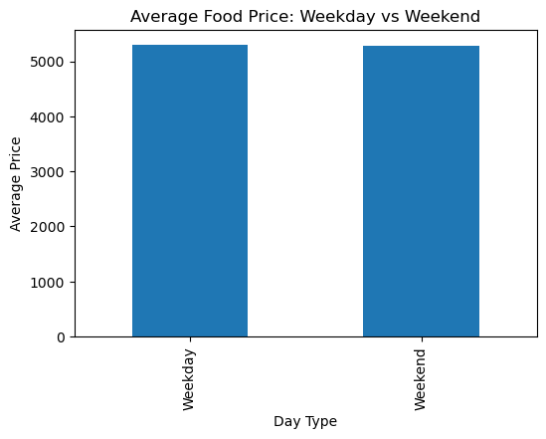

8. Most Expensive Food Items
When comparing average prices across food categories, rice appears as the most expensive item in the dataset. Other relatively expensive foods include oil, yam, milk, and tomato. Because these products are widely consumed staple foods, increases in their prices can significantly affect household spending and food affordability.
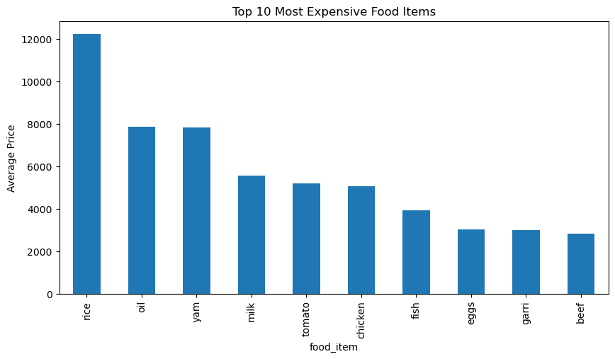

9. Correlation Analysis
A correlation analysis was conducted between price and several numerical variables, including latitude, longitude, year, and month. The results indicate generally weak relationships. Geographic coordinates show only a small positive correlation with price, suggesting that location may influence price differences slightly but does not strongly determine price levels. The year variable shows a modest positive correlation with price, which aligns with the overall upward trend observed in the time-series analysis. In contrast, the month variable shows almost no relationship with price, indicating that seasonal effects are limited within the dataset.
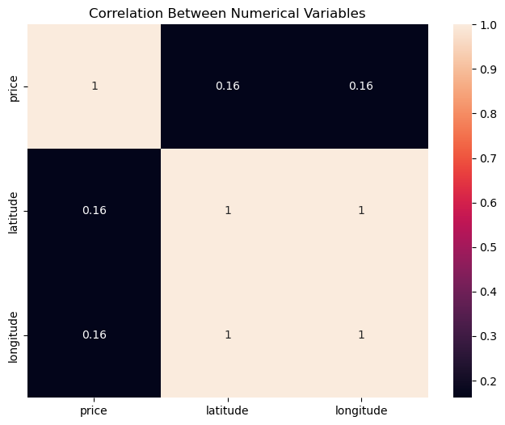

10. Price Distribution
The distribution of the price variable is highly skewed. Most observations fall within a moderate price range, while a small number of records contain extremely high values. Because of this imbalance, statistical modeling using the raw price variable may be affected by outliers. Applying a logarithmic transformation would help reduce skewness and produce a more balanced distribution for predictive modeling.
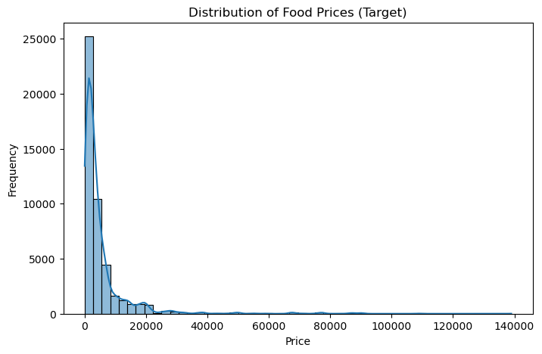 | 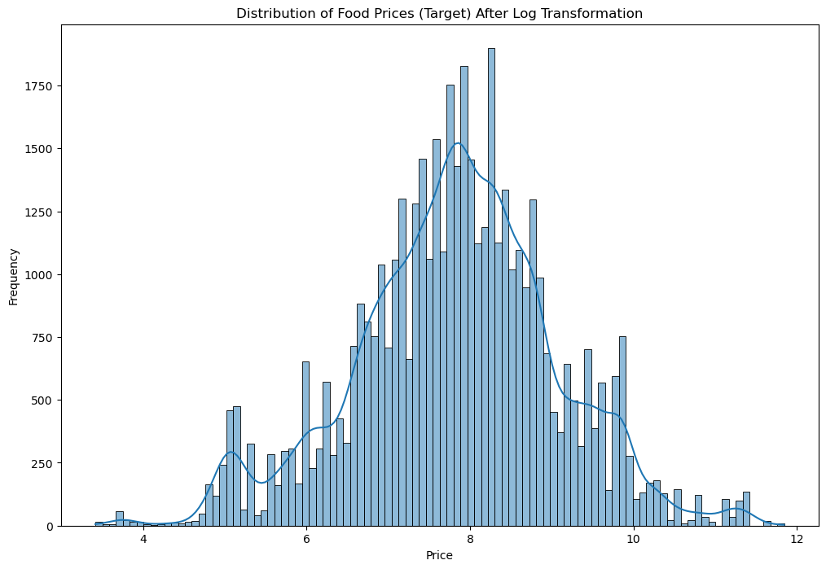

11. Major Findings
Several important insights emerge from the exploratory analysis. Food prices show a clear upward trend over the eight-year period, with the most significant increases occurring between 2020 and 2024. Rice, oil, and yam are among the most expensive items on average and display strong price growth over time. Supermarket prices are considerably higher than government-recorded prices, highlighting differences in retail environments and distribution systems. Weekly comparisons show minimal variation, suggesting that food prices are largely influenced by long-term economic conditions rather than short-term demand fluctuations. The analysis also shows that geographic variables and calendar features explain only a small portion of price variation. In addition, the price distribution contains extreme values, which indicates the need for transformation when developing predictive models.

12. Conclusion and Implications
This analysis provides a comprehensive overview of food price movements in Nigeria between 2016 and 2024. The results clearly indicate that food prices have increased over time, with particularly strong growth in the most recent years. Staple foods such as rice, oil, yam, milk, and tomato account for some of the highest price levels in the dataset. Since these items represent essential components of household consumption, rising prices in these categories may place additional financial pressure on consumers.
The difference between supermarket and government prices also highlights the role of retail structures and distribution systems in shaping market prices. Although geographic location and seasonal factors appear to have only a limited effect on price variation, the overall upward trend suggests broader economic influences affecting the food market.
Future research could expand this analysis by incorporating additional variables such as transportation costs, agricultural production data, and regional economic indicators. Integrating these factors into predictive models could improve the ability to forecast food price changes and support decision-making related to food security and economic planning.

